Map of the area around El Camino College

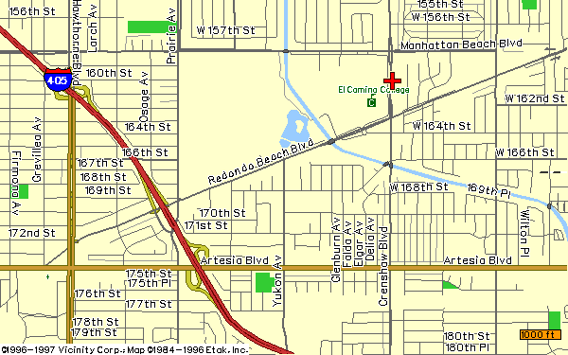

STUDENT

HOUSING

INFORMATION

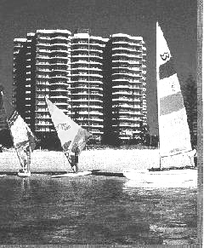
EL CAMINO COLLEGE

Global Student Services®
Housing Locator Program

Global Student Services representatives will help you to find the friendly family at the right location to make your stay in the United States more memorable through the available homestay program. The homestay option will provide students with many opportunities to speak English and learn about American culture.

Homestay Services

Application Fee: $200.00 (Non-refundable)
Security Deposit: $250.00
Airport Pickup: included in the homestay prices

Homestay options:

- Homestay with (2) meals (Breakfast & dinner)
- Homestay without meals

Apartment Locator Services:

Application Fee: $200.00 (Non-refundable)
Security Deposit: $500.00
Airport Pickup: included in apartment prices
Paid utilities (electricity, water & gas)
Basic furniture if requested

Apartment options:

- Single studio apartments
- 1-bedroom apartment

For more information and application, please contact:

Global Student Services, USA®
3435 Ocean Park Blvd. Suite 202
Santa Monica, CA 90405
USA
Tel:(310) 314-0091
Fax:(310) 314-0092
E-mail: gssusa@aol.com
http://www.global-student-service.com/
California State Dominguez Hills Student Housing

All international students currently enrolled at El Camino College are eligible for the housing at California State Dominguez Hills.

Student Apartments at Cal State Dominguez Hills include these features:
- Fully furnished rooms
- Full kitchen with stove and refrigerator
- Free basic cable access provided in each unit
- All utilities included in rental fees except telephone service
- PC/ Mac computer lab with free Internet/e-mail access
- Laundry facilities
- Basketball and volleyball courts/Weight-lifting room
- 24-hour live-in staff and security

Summer Rental Services

- 1-bedroom, Double Occupancy $1232*
- 2-bedroom, Double Occupancy $ 936*
- 3-bedroom, Single Occupancy $1360*

Academic Year Rental Fees

- 1-bedroom, Double Occupancy $4032*
- 2-bedroom, Double Occupancy $3066*
- 3-bedroom, Single Occupancy $4584*

(Payments can be made in Two or Three installments.)

Apartment Furnishings
- Two twin beds
- Desk, chair, and bookshelves
- Dresser & closet
- Sofa and love seat
- Dining table and chairs
- Stove, oven, and refrigerator

For more information and application, please contact:

Student Housing Office
Cal State Dominguez Hills
P.O. Box 6228
Carson, CA 90746-6228, USA
Tel: (310) 243-2228
E-mail: AMARCEL@csudh.edu
http://www.csudh.edu

Private Apartments*

Apartments are available in Torrance and areas around El Camino College. Following are some apartments within walking distance from El Camino College. Students are encouraged to contact the owners or managers directly for rental arrangements.

Alondra Park Apartments…………. (310) 323-2652
Cerise Apts……(877) 215-6408 Fax (323) 935-3605
Il Pompeii ……………………… (310) 327-3681
Park Yukon Apartments ………… (310) 516-0526
Pueblo Condo …………………… (310) 327-3424
Torrance Garden Apartments ...… (310) 324-1494
Torrance Terrace Apartments …… (310) 327-2599
Tropic Isle Apartments …………… (310) 323-8028
Apartments (close to the campus)… (310) 541-1690

* More apartments are available at Redondo Beach Blvd., Yukon St. and Artesia Blvd. (price ranges are from $500
to $800).

You can find additional information about available apartments from local publications such as the "Rental Outlook" or "Daily Breeze". Both papers are available
on and off the ECC campus.

Find apartments by using the Internet at
www.sar.adone.con or www.aprtments.com or
www.rent.com (use the Search by Keyword section
and type in it " Torrance," “Hawthorne,” Lawndale”, “Gardena,” or “El Camino”).

Some Local Hotels and Motels

Days Inn ($65) 15636 Hawthorne Blvd.
(Near the college) Lawndale, CA 90260

Tel:(310) 676-7378 Fax:(310) 676-3138

Tel:(310) 318-6132 Fax:(310) 372-9134

Best Western ($75) 2740 Artesia Blvd.
Redondo Beach Redondo Beach, CA 90278

Tel:(310) 370-4353 Fax:(310) 793-7135

Ramada Inn ($55) 2880 Pacific Coast Hwy.
(Big rooms) Torrance, CA 90505

Tel:(310) 325-0660 Fax:(310) 325-6661

Transportation

You can receive information about bus and metro service by calling: (310) 320-9442 or 1(800) 266-6883.

