**ENTERING PROGRAM PLANS AND LINKING THEM TO PROGRAM REVIEW ON TRACDAT**

**STEP 1**

Click on the  **button** to the far right of **Recommendations** to add a new goal.



**STEP 2**

The following fields appear on the Add Recommendation or Edit Recommendation pages. An asterisk (*) by a field denotes that it is required.

|  |  |
| --- | --- |
| **Fields** | **Content to enter into TracDat** |
| **\*Recommendation Name** | Use the following naming convention:  **[Unit-Abbrev.] [Program-Name] [Fiscal-Year] “Rec” [Unique-Number]**  Example: *2018-19 BCC HDEV Rec 1*  Clarity, consistency, and brevity are key to the planning processes as recommendations migrate up to the College Plan.  **AVOID** Recommendation Names that:   * List the requested item as part of the Rec Name. Save this for the **Recommendation** field. * Include references to the Program Review – This linkage will be handled in **STEP 4**. * Use lengthy phrases. |
| **\*Recommendation** | Input the Recommendation text here (e.g., Hire full-time faculty in Painting/Drawing, or Purchase MS-Widget to support graduation efforts). Please limit the description of the recommendation to one to two sentences; more detail can be provided in **Rationale & Expected Outcome**. |
| **Recommendation Status** | Select the appropriate status. Begin with **Not Started** |
| **Implementation Timeline** | *This field is not marked with *, but it is important to include an implementation timeline. This will help when generating reports in excel or PDF format for the College Plan.*  Click on the empty field and select the**academic or fiscal year**for anticipated/desired implementation of the recommendation. |
| **Input/Last Revised Date** | Enter today’s date; revise this date when changes are made. |
| **Completed Date** | Leave blank. |
| **\*Origin of Recommendation** | Select the source of your Recommendation (**Program Review**, **Emerging Need**, **Other**). If you select **Program Review** as the source, please be sure to complete **STEP 4**. |
| **\*Expense Category** | Select an expense category that most closely relates to your recommendation. Select ‘**Other**’ if the Recommendation needs no funding. |
| **Program Rank** | Select priority number for the Recommendation within the given expense category. |
| **\*Rationale & Expected Outcome** | Briefly describe the rationale for your request; sketch out an evaluation plan. |
| **\*Anticipated Cost** | Use whole numbers (integers) only. Enter ‘0’ if no cost is involved. |
| **\*Primary SI Supporting Recommendation\*** | Select the SI for which the recommendation will support. |
| **\*Any Impact on Other Programs, Areas or Units?** | Mark **Yes** if recommendation has an impact on other programs, areas, or units. |
| **List impacted areas and describe potential impact** | If ‘**Yes**’ was selected in previous field, list all programs that would be potentially impacted by the recommendation and briefly describe potential impact. |
| **\*Funding Status** | Set Funding Status to **Proposed**  or **N/A**. |
| **\*Funding Type** | Select the appropriate Funding Type |
| **Annual Evaluation Date** | Leave blank. This will be completed after the close of the year. |
| **Annual Evaluation** | Leave blank. This will be completed after the close of the year. |

**STEP 3**

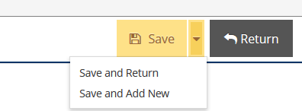After completing all necessary fields for your new

recommendation, you must **Save** it. Click the gold ***Save***

button in the upper right corner before leaving the page.

You may select the carrot on the ***Save*** button to either

**Save and Return** to your list of Recommendations or

**Save and Add a New** Recommendation. Click the **Return**

button to go back to your Recommendations page.

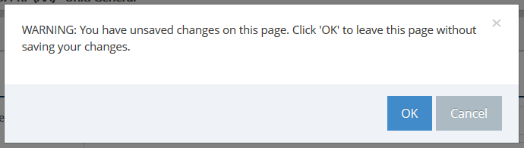If you try to return without

saving changes, the system

will prompt you to confirm

this. To go back and save

your changes, click **Cancel**.

**STEP 4**

If the **Origin of Recommendation** is your Program Review, you will need to link the relevant component to your Program Review to the Recommendation using the following process.

**FIRST**, visit your Program Review document, either in TracDat or a separate document. Leave this document open or accessible as you will need it later.

Click the link under the Recommendations column on the Home Screen. This will *expand* the information you can see. If you are on the Program Review & Planning page, click the **carrot to the left of the Recommendation** to expand. *Do not open or “Edit”* the Recommendation.

To link a Program Review Component, Click on the  button to the right. 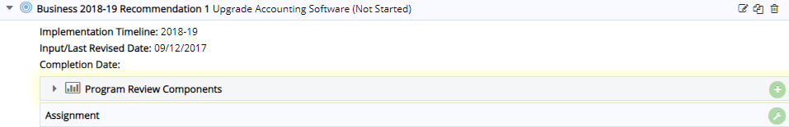

This opens the Add Program Review Component dialog box. Select the appropriate **Component** **Category** by **clicking the drop-down list**. 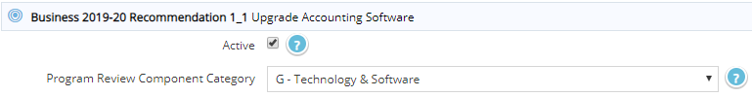

Then enter the recommendation from the Program Review into the **Program Review Component** field. 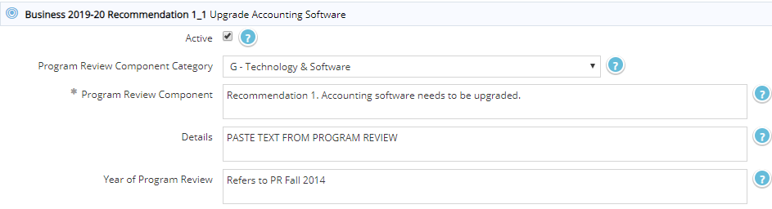

**COPY** the relevant text that supports the need for your Recommendation. You need not copy lengthy content, just enough to support your Recommendation and show the linkage from Program Review. **PASTE** the relevant text from program review into the **Details** field. This text should justify your need for the Recommendation.

Though not required, you may choose to enter your program review year in the **Year of Program Review** field.

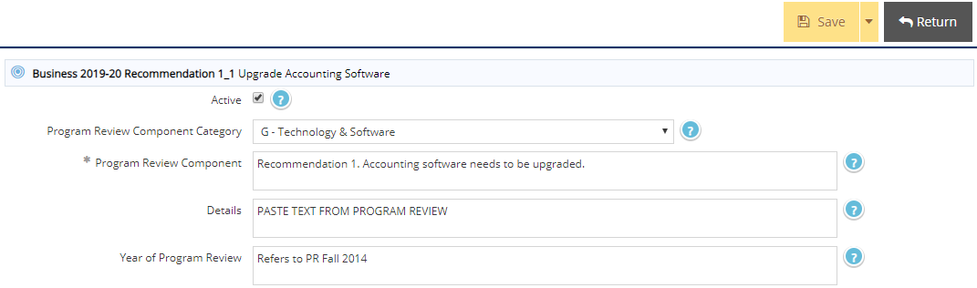When each Component field is complete, click **Save**. Then click **Return** to go back to the Recommendation and Components. This field does not currently support rich text formatting (bold, italics, hyperlinks, etc.) or graphs/tables.

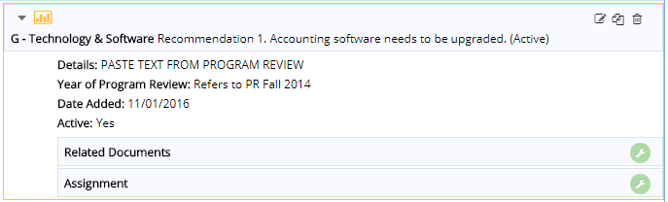

You may wish to associate related documents

by clicking the **Related Documents Settings**

icon. This feature may be used to attach

any supporting documentation with graphs,

tables, etc. to a specific recommendation.

The supporting program review component is now linked to your recommendation and the link will print along with the Recommendation in standard reports.

**YOU MAY ALSO COPY OLD RECOMMENDATIONS FROM THE PREVIOUS YEAR AND EDIT THEM.**

**STEP 1**

Locate the old Recommendation that you would like to copy. Click on the **Copy** icon next to the Recommendation.

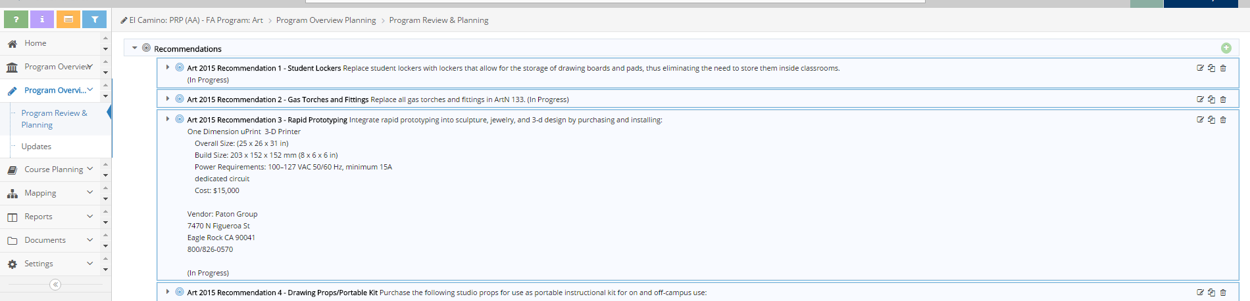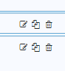

**STEP 2**

**PASTE** the Recommendation into your list by selecting the **Program** from the left-handed list. Check to ensure the **Program** is highlighted in blue, as shown.

Use the **single arrow** to move the recommendation over. Click **Save** and **Return**.

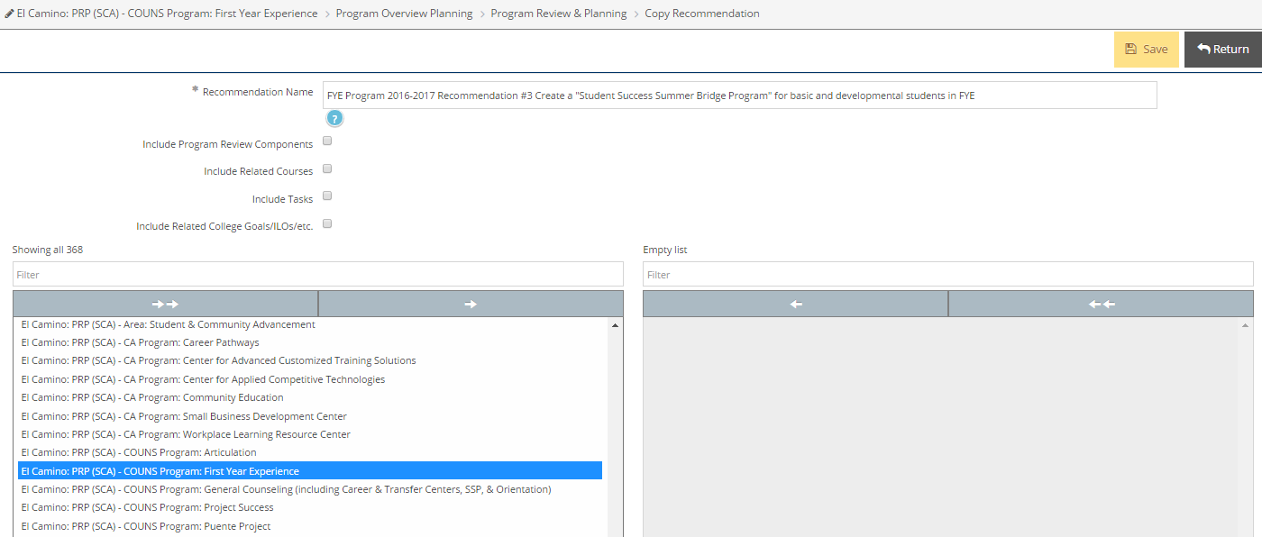

  
The copied Recommendation will appear at the bottom of your recommendation list. To move the Recommendation up to the top, click and hold the blue **bull’s eye** () to the left of the Recommendation and move it up or down.

**STEP 3**

Click on the **Edit** icon located to the left of the Recommendation.





**EDIT** the applicable fields, including the **Recommendation Name** and **Implementation Timeline** to reflect the fiscal year.