|  |  |  |  |
| --- | --- | --- | --- |
|  | **Name** |  | **Division** |
|  | Analu Josephides* | AJ | Library & Learning Resources |
|  | Christina Nagao | CN | Humanities |
|  | Edith Gutierrez | EG | Manager Representative |
|  | Erika Yates | EY | Classified Representative |
|  | Eunice Tuuholoaki | ET | Student Representative; MANA |
|  | Gary Medina | GM | Library & Learning Resources |
|  | Joseph Hardesty | JH | Fine Arts |
|  | Jason Suarez | JS | Behavior Social Sciences |
|  | Ketmany “Katie” Sundara | KS | Dean Representative |
|  | Linda Cooks** | LC | Library & Learning Resources |
|  | Maria Barrio de Mendoza | MM | Humanities |
|  | Melissa Fujiwara | MF | Behavior Social Sciences |
|  | Nayeli Oliva | NO | SEA |
|  | Polly Parks | PP | Natural Sciences |
|  | Rebecca Donegan | RD | Natural Sciences |
|  | Robert Williams | RW | Counseling |
|  | Salinas, Nael | NS | Student Representative; ASO/ICC |
|  | Sheryl Kunisaki | SK | Manager Representative |
|  | Susan Nilles | SN | Health Sciences & Athletics |
|  | Habiba Amir | HA | Student Representative; ASO |
|  | Terriona Ellis | TE | Student Representative; ASO |

*Committee Chair **Minutes

**Mission Statement:** *The El Camino College Equity, Diversity, & Inclusion Standing Committee provides guidance to the Academic Senate on matters related to equity, diversity, and inclusion under the 10+1. Under this purview, this committee will create and implement concrete plans that will increase equity in teaching, learning, and serving our students as well as in relationships among colleagues.*

**Fall 2021 Meetings:** Thursday’s, February 24, March 10 & 24, April 7 & 21, May 5 & 19, June 2

|  |  |
| --- | --- |
| **Agenda Item** | **Action** |
| **Introduction**   * New Members |  |
| **Approval of Minutes**   * **March 10th, 2022** | Vote  p. 3 - 5 |
| **Old Business**   * Informed and Inspired * Land Acknowledgment * EDI Mental Health Resolution | Update  p. 5 |
| **New Business** |  |
| **Future Agenda Item**   * Goals 22-23 |  |

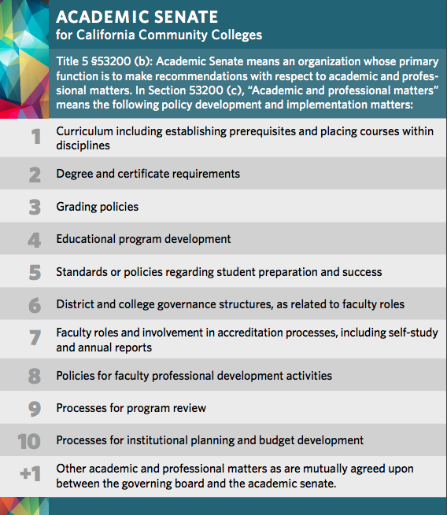

**Informed and Inspired**

Last Thursday of the month, Thursday, May 26th from 1:15-2:15, on Zoom

*Creating Community and Centering Cultural Capital*:  Thursday, April 28, 1:15-2:15 and Friday, April 29, 10:00-12:00​

**Land Acknowledgement toolkit workshop**

Monday, May 23rd and Monday, June 6th 1pm to 2pm.