|  |  |  |  |
| --- | --- | --- | --- |
|  | **Name** |  | **Division** |
|  | Analu Josephides* | AJ | Library & Learning Resources |
|  | Christina Nagao | CN | Humanities |
|  | Edith Gutierrez | EG | Manager Representative |
|  | Erica Brenes | EB | Humanities |
|  | Erika Yates | EY | Classified Representative |
|  | Eunice Tuuholoaki | ET | Student Representative; MANA |
|  | Gary Medina | GM | Library & Learning Resources |
|  | Habiba Amir | HA | Student Representative; ASO |
|  | Hong Herrera Thomas | HHT | Behavior Social Sciences |
|  | Joseph Hardesty | JH | Fine Arts |
|  | Jason Suarez | JS | Behavior Social Sciences |
|  | Ketmany “Katie” Sundara | KS | Dean Representative |
|  | Linda Cooks** | LC | Library & Learning Resources |
|  | Maria Barrio de Mendoza | MM | Humanities |
|  | Melissa Fujiwara | MF | Behavior Social Sciences |
|  | Nayeli Oliva | NO | SEA |
|  | Polly Parks | PP | Natural Sciences |
|  | Rebecca Donegan | RD | Natural Sciences |
|  | Robert Williams | RW | Counseling |
|  | Salinas, Nael | NS | Student Representative; ASO/ICC |
|  | Sheryl Kunisaki | SK | Manager Representative |
|  | Susan Nilles | SN | Health Sciences & Athletics |
|  | Terriona Ellis | TE | Student Representative; ASO |

*Committee Chair **Minutes

**Mission Statement:** *The El Camino College Equity, Diversity, & Inclusion Standing Committee provides guidance to the Academic Senate on matters related to equity, diversity, and inclusion under the 10+1. Under this purview, this committee will create and implement concrete plans that will increase equity in teaching, learning, and serving our students as well as in relationships among colleagues.*

**Spring 2022 Meetings:** Thursday’s, February 24, March 10 & 24, April 7 & 21, May 5 & 19, June 2

|  |  |
| --- | --- |
| **Agenda Item** | **Action** |
| **Introduction**   * New Members | Erica Brenes |
| **Approval of Minutes**   * **April 7th, 2022** | Vote  p. 3 - 4 |
| **Old Business**   * EDI Mental Health Resolution * Informed and Inspired * Land Acknowledgement Toolkit * Impact Equity Grid Training (Symbols and Logo’s) | Update  See external attached document  p. 4  p. 4  See external attached document/link |
| **New Business** |  |
| **Future Item:** EDI Champions: Honoring ECC’s Community |  |

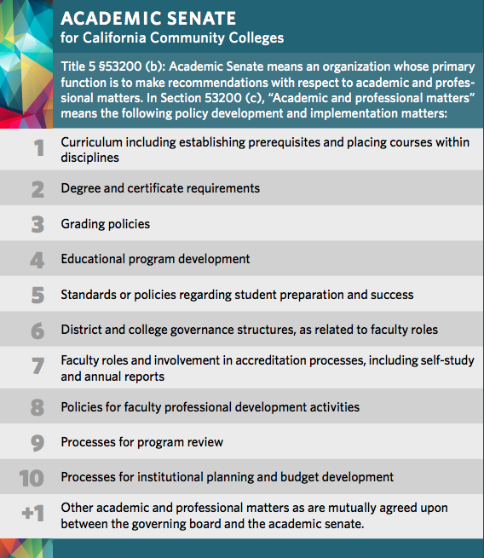

**Equity, Diversity, & Inclusion (EDI) Standing Committee Meeting**

**Minutes for Thursday, April 7, 2022 1:00 – 2:00 pm**

|  |  |  |  |
| --- | --- | --- | --- |
|  | **Name** |  | **Division** |
| X | Analu Josephides* | AJ | Library & Learning Resources |
| X | Christina Nagao | CN | Humanities |
|  | Edith Gutierrez | EG | Manager Representative |
| X | Erika Yates | EY | Classified Representative |
|  | Eunice Tuuholoaki | ET | Student Representative; MANA |
| X | Gary Medina | GM | Library & Learning Resources |
| X | Habiba Amir | HA | Student Representative; ASO |
| X | Hong Herrera Thomas | HHT | Behavior Social Sciences |
| X | Joseph Hardesty | JH | Fine Arts |
|  | Jason Suarez | JS | Behavior Social Sciences |
|  | Ketmany “Katie” Sundara | KS | Dean Representative |
| X | Linda Cooks** | LC | Library & Learning Resources |
|  | Maria Barrio de Mendoza | MM | Humanities |
| X | Melissa Fujiwara | MF | Behavior Social Sciences |
|  | Nayeli Oliva | NO | SEA |
|  | Polly Parks | PP | Natural Sciences |
|  | Rebecca Donegan | RD | Natural Sciences |
|  | Robert Williams | RW | Counseling |
|  | Sheryl Kunisaki | SK | Manager Representative |
| X | Susan Nilles | SN | Health Sciences & Athletics |
|  | Terriona Ellis | TE | Student Representative; ASO |

* Committee Chair **Minutes

**Mission Statement:** *The El Camino College Equity, Diversity, & Inclusion Standing Committee provides guidance to the Academic Senate on matters related to equity, diversity, and inclusion under the 10+1. Under this purview, this committee will create and implement concrete plans that will increase equity in teaching, learning, and serving our students as well as in relationships among colleagues.*

Meeting Started at 1:05 pm

# Introduction

* Add new members - None

# Approval of Minutes

* Meeting minutes from 3-7-22 were approved.

**Old Business**

* Informed & Inspired (I&I) – I&I seminar and panel discussion on the topic of What is a Warm Demander took place on Thursday and Friday, 3-31 & 4/1. The next seminar/panel discussion will take place on Thursday, 4/28 from 1:15 – 2:15 pm and Friday, 4/29 from 10 am – 12 pm. The topic is Creating Community and Centering Cultural Capital.
* The newly formed sub-committee, EDI Mental Health Task Force, met to discuss goals. SN is Chair for the sub-committee and HH and AJ are the members. The first goal is to develop a resolution on mental health. The Board of Governors recently passed a resolution regarding mental health. We are basing our resolution on the Board of Governors’. A draft has been created by AJ and will be reviewed by SN and HH. The draft will be sent out to the group for review. We will discuss the resolution and any recommendations at the next meeting.

The second goal is to send out the mental health survey “Healthy Minds” to ECC in May which is Mental Health month. AJ wants the Standing Committee to endorse, promote and disseminate it –encourage our colleagues to get it into the hands of the students. SN stated that ECC needs a campus mental health case manager. SN is being asked for data to support this need. Presently a basic needs manager is being hired.

Third goal is to send something to the Deans and Directors (i.e, those in charge of people) to get the number of people that they know need mental health assistance.

* + CN – How do you get students to talk about mental health or motivate them to access mental health resources?
  + SN – 1) encourage one to one consultation; 2) Conduct workshops and follow-up afterwards; 3) Personalize it.
  + HH – Encourage students to journal. Build aspects of mental health care within the curriculum.
* Impact Equity Grid – HH asked that the sub-committee review the images, logos, and symbols of ECC branding. LC noted that a section of the library exhibit will discuss ECC logos, seals and branding. JH suggested that ECC consider changing its name. HH noted that when people come to their own conclusions that something needs to change, it is much more powerful and sustainable.

Meeting ended at 2:00 pm

**Informed and Inspired**

Last Thursday of the month, 1:15-2:15, on Zoom (3/31, 4/28, 5/26)

* *Creating Community and Centering Cultural Capital*:  Thursday, April 28, 1:15-2:15 and Friday, April 29, 10:00-12:00​

**Land Acknowledgement toolkit**

Hour presentation on Monday, May 23, 2022 and June 6, 2022 at 1pm. Register in Cornerstone.

Zoom: <https://tinyurl.com/3ay765b8>