**ESL Meeting on 5/25/21**

In attendance: A. Carr, E. Geraghty, M. Kline, R. Loya, D. Mochidome, J. Simon, E. Uyemura, L. Dellapasqua, N. Nitchen

D. Breckheimer, K. Degnan, S. Kushigemachi, M. Mattern, H. Wada

* SLOs (Mora)
  + Mora will send out a reminder email to the sections that are being assessed.
  + Noncredit courses will all be “NESL”
  + This is Mora’s last semester as SLO coordinator. Anna Mavromati will take over in the fall.

* Proposed Program Review Timeline Adjustment (Kevin)
  + Timeline for ESL will be Fall 2023

Kevin asked if ESL department would be willing to trade presentation timeline with Theater (Fall 2022). ESL cannot trade at this time because of the pandemic and issues with international students.



* Changes to Program Review and Annual Planning Templates (Kevin)
  + Kevin went over the changes in Program Review. Program Review is every 4 years but what is new is annual assessments in planning.



* Event – Discussion on Racial Literacy with Keith Knight -Cartoon Artist (Kevin)
  + Wednesday, May 26 from 2:00-3:00. See flyer attached:



* ODE Mentor for Humanities (Laila)
* Laila and Ryan Martinez will have a workshop this Friday, May 28 from 2:00-3:00 on PlayPosit

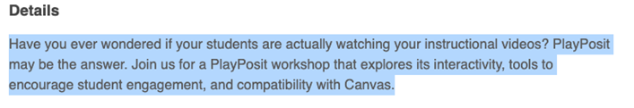

For flex credit, go to Cornerstone to register.

Zoom Link: <https://elcamino-edu.zoom.us/j/95319664524>

* Faculty Evaluations (Scott)
  + There were comments that there needs to be clarification on submitted the self-evaluations. In the future, there will be reminders/instructions emailed as things are due.

* Grade Submission for NC ESL (Scott)
  + Scott will be sending out an email on how to submit NC ESL grades.
* Curriculum (Scott)
  + Unit Increase Approved by Screening Committee
  + CCC should approve soon and the unit increase to 5 units will start Fall 2022.
* Academic Senate Update (E-mail Forthcoming)
  + Elayne Kelley will be sending out the update soon.
* Equity Syllabus Statement (Everyone)
  + See attached
  + Debra Mochidome shared a revised version of the statement. Input from everyone on wording of the statement.
  + Scott will discuss with Gary Greco regarding the term “ability status”.
  + The statement will be included on the fall 2021 syllabus templates.

Draft ESL Equity Statement:

*The ESL Department at El Camino College believes that all students from every background have the ability to learn and to succeed. We strive to treat students of every language, culture, race, gender, religious (or non-religious) and political beliefs, gender or sexual identity, socioeconomic and educational background, and immigration status equitably and respectfully. We are open to your ideas and viewpoints, and we ask you to be open and respectful to your classmates, who come from many different circumstances. Our goal is to help you increase your knowledge of English, but we also acknowledge and respect your right to maintain your native language. We recognize your strengths and your unique viewpoints and experiences.*