Course Topics:
- Creating Mail Merge Files
- Creating Mailing Labels
- Printing Selective Records
- Using Mail Merge Toolbar
- Envelopes and labels “on the fly”

Section 1 – Creating Mail Merge Files
The Mail Merge feature is used to quickly produce letters and labels from a database and to choose which fields you wish to include from within that database.
Mail Merge takes place in three stages:
- creation of the Main Document,
- creation or attachment of the Data Source,
- finally the merging of the two into a finished product.

Step 1: Create a New Mail Merge Letter.
1. Create a new blank document.
2. Choose Tools > Letters and Mailings > Mail Merge.
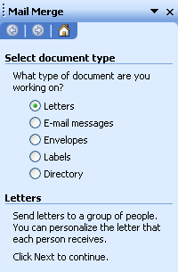
The Mail Merge Helper task pane displays on the right. Ensure Letters is selected.
3. Click Next: starting document at the bottom to begin creating the Starting Document.
4. Select Use the current document in the Select starting document area, then click Next: select recipients.

Step 2: Creating a New Data Source for the Mail Merge
- Under Select recipients, select Type a new list, and then click on Create….

The New Address List dialog box appears.
Many common fields for any database are displayed with entry boxes for inputting information.
To remove fields, click the Customize button, then select the desired field and click Delete.
To add your own custom field, click the Customize button, then click the Add button. Type in the name for the new field and click OK.
- Click Customize and Delete the fields “Address Line 2” and “Home Phone”.  - Add the field “Job Title”. Click OK to accept the field names. Use the Move Up or Move Down buttons to position the Job Title field to be under Last Name. Click OK  - Input data (names, addresses, etc.) to the appropriate fields from the list provided by the instructor. | 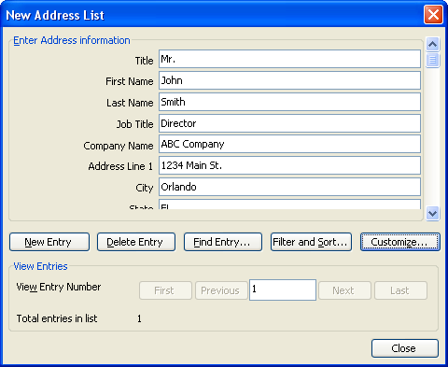

NOTE: Use the Enter or Tab key to move from one field to another. Scroll down to enter the Country and Work Phones.
NOTE: After you key in the last field for each person, or
press New Entry to create a new blank record for the next person. You can move between entries with the Previous/Next buttons.
- When finished, click Close to prompt the Save Data Source dialog box; Save the data file as “My Data” in the Training folder.
The Mail Merge Recipients dialog box displays, showing your data.
6. Click OK.
The Main Document (currently empty) and task bar display again. Now, ‘Use an existing list’ is selected and currently shows your “My Data.mdb” as its target source.
NOTE: that above the Main Document, the Mail Merge Toolbar has appeared:
If you wish to make changes to your My Data list, you can open it up by clicking on the Mail Merge Recipients button on the toolbar , then clicking the Edit button.

Step 3: Creating the Main Document
- Click on Next: Write Your Letter.
- On the Mail Merge toolbar, click the Insert Merge Fields button to open a list of fields to place into the letter. Select the desired field and click the Insert button. Click the Close Button to exit.
Remember to use the spacebar to space between field names, and commas where appropriate-- just as you would if you were typing each piece of data on a separate letter.
Use standard formal addressing and salutation settings for this letter.
- Type the text that will be common to all letters in this merge.
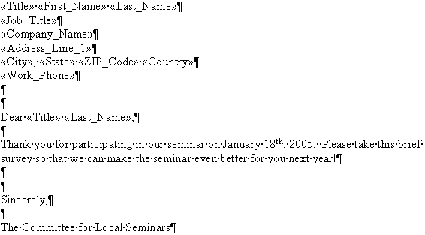
- Save the letter as “letter.doc” in the Training > Mailmerge2003 on the desktop folder before attempting to merge.
Step 4: Merging Documents and Data
- In the Mail Merge task pane, click Next: Preview your letters (or click the View Merged Data button on the Mail Merge taskbar ).
Microsoft Word displays information from the first data record in place of the merge fields.
- Click Next: Complete the merge.
You can either complete the merge by printing or within a new document.
  - To print you letters, click Print on the Mail Merge task pane (or click the Merge to Printer button in the Mail Merge toolbar ).
Please do not print from the training room!
  - To create a new document with your merged letters, click Edit individual letters on the Mail Merge task pane (or click the Merge to New Document button in the Mail Merge toolbar ). This will allow you to make changes to individual letters before printing.
- Click to Edit individual letters.  The Merge to New Document dialog box appears.  4. Select the range of records to merge, or click All, then click OK.  Word performs the merge and produces a new document containing the results of the | 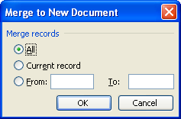
merge. Review these merged documents to ensure that all elements are included and look properly arranged on the page.
4. Save the data file as “Merged Letter.doc”, then Close the document.
Working with an Existing Data Source File
1. Choose File > Open.
2. Open the file called “Clients”.
a. The file displays as a database document, which is the same as a Word table. The field headings must be the first row in the table for this to be recognized as a data list. Word handles data lists differently than normal paragraph text:
Field: a specific category of information (First Name, Last Name, Address1, etc.). Fields are the same as columns.
Record: a set of fields relating to one unique item (person, company, etc.). Records are the same as rows.
Data: the specific entries within each field
b. You can resize the fields in this document the same way you resized table borders, by clicking and dragging with the double arrow on any vertical line.
c. You may also print the data document as you would any other file.
3. To turn off or display the non-printing gridlines on the screen, choose Table > Hide/Show Gridlines .

Sorting Records
- Turn on the Database Toolbar (View > Toolbars > Database, or right-click any toolbar and choose Database).

2. Click anywhere in the Last Name field.
3. Click the Sort Ascending (A-Z) button on the Database Toolbar.
4. Click the Sort Descending (Z-A) button to sort in reverse order.
5. Experiment by sorting in order of Postal Code, City, State, etc.

Sorting Records by Multiple Codes
1. To sort by multiple fields, choose Table > Sort.
The Sort dialog box displays.
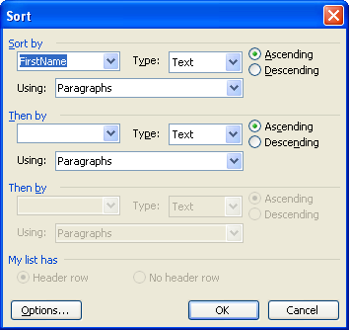
- Choose up to three levels of sorting
(such as by Postal Code, then by Last Name, then by First Name).

Using a Data Form
1. Click the Data Form button on the Database Toolbar.
The Data Form displays.
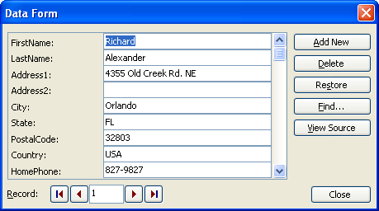
- Click the Record Navigation buttons (Next, Previous, First, Last) to scroll through the records one-by-one.
3. Click the Add New button to add a new record.
4. Type your own personal information as the new record.
5. Click in the Record Navigation number area. Type in “15” and press Enter to jump to record 15.
6. Click the First button to jump to the first record.
- Click the Find button on the form. Type “Wong” in the Find what: area, then choose “Last Name” in the In Field: area.
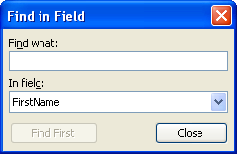
8. Click the Close button on the Find in Field dialog box, then make any necessary changes to the record.
9. Close the Data Form window.
NOTE: that there is a Find Records feature on the Database Toolbar to find records in the regular datasheet (table) view.
11. Turn off the Database Toolbar, and Close the “Clients” file.

Section 2 - Creating Mailing Labels
Repeat the steps for creating a mail merge document (open a new document, go to Tools > Letters and Mailings > Mail Merge), with the following exceptions:
1. Select Labels instead of Letters as the document type.
2. For your starting document, Change the document layout by clicking on Label Options.
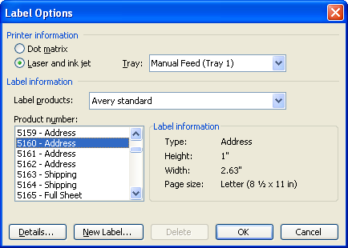
Choose Avery Standard 5160 - Address as the type of labels to be used for the Main Document.
3. For your recipients, use the existing list called “Clients” instead of typing a new list.
- For Arranging your labels, layout your first label on the sheet by clicking Address block. Review the address elements and click OK.
- Replicate this format for the entire sheet by clicking the Update all labels button.
- Preview and Merge your labels as before, though labels are usually printed directly and not saved as a document.

Section 3 - Printing Selective Records
1. In your main labels document, open the Mail Merge Recipients dialog box (using the button on the Mail Merge toolbar.)

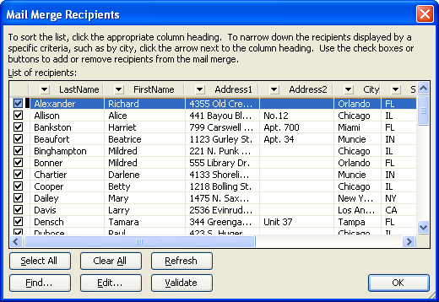

From here, you can:
  - Use the check boxes on the left to designate recipients
  - Sort items alphabetically by clicking the desired column heading
  - Filter items using the down arrow next to the column heading
2. Click the down arrow next to a field name that contains the data you want to filter. A list appears with appropriate filtering options.
For our example, we will use the State field. Click the down arrow next to State and select FL for Florida.
The down arrow turns blue, and the merge preview runs again showing only the records that match the criteria selected from the list (only those with FL in the State field). | 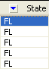
NOTE: For more sorting and filtering options, click one of the down arrows and select (Advanced…). This will let you enter in more thorough information to sort/filter by, rather than selecting from a list.

Section 4 - Using the Mail Merge Toolbar
When working with a merge document, Word automatically displays a special Mail Merge Toolbar. This toolbar contains several shortcut buttons that make it easier to use the mail merge feature.
1. Use the Merge to New Document button to shortcut to a new document merging all records or using the current sort/filter options.
2. Use the Merge to Printer button to shortcut to send the results of the merge directly to the printer.
3. Use the View Merged Data button to see the results of the merge without actually creating a new document.
4. Use the Mail Merge Recipients button to shortcut to a table of the recipients without having to open the source data file separately.
Section 5 - Using Envelopes and Labels to print a few labels (or even just one) “on-the-fly”
Occasionally, you just want to print a single label, a whole sheet of the same label, or a single envelope, all without using the Mail Merge feature. Word has a separate “Envelopes and Labels” feature to handle these special needs.
1. Start a new document, then choose Tools > Letters and Mailings > Envelopes and Labels.
The Envelopes and Labels dialog box displays.
- Click the Labels tab.
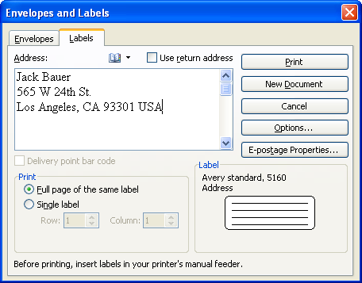
3. Type a name and address in the label area, exactly as you would want it to appear when printed.
4. Click the Options button to change the type of label being used.
5. In the Print: area, choose one of the following:
Full page of the same label: prints the same label multiple times, until the format you have selected is filled (e.g., 30 Avery 5160 labels)
Single label: prints one label. When you choose this option, the area below it activates for you to enter the number of rows across and columns down you would like the printer to go before starting to print. (For instance, you may have a sheet of labels on which some have been used, and you want the printer to go down two rows and one across one column to print the desired label.) Not all printers will feed used label paper correctly.
- Click Print to print your label(s).
Microsoft Word 2003

Mail Merge & Labels
LaTonya Motley
Trainer / Instructional Technology Specialist
Staff Development
660-6452

Computer Resources
Unlimited

