EL CAMINO COLLEGE
First Year Experience
PROGRAM REVIEW

Program Description
Describe the program emphasizing the program’s objectives and how the program supports the college’s mission and vision statements, strategic initiatives, and core competencies.
The First Year Experience (FYE) program is designed to assist new and continuing students transitioning from high school to college with their academic goals that consist of degree and or certificate attainment as well as transfer. The program enhances student success by offering a comprehensive summer orientation, academic counseling, and assistance to each student with financial aid resources such as: fee waivers, federal Pell grants, and scholarship assistance. Further, the program offers each student with a MyECC portal orientation thereby providing students with the necessary tools to monitor their financial aid disbursement, class schedule, academic transcripts, and registration for classes. FYE uses an integrative approach to teaching and learning where students participate in multiple learning communities for an entire academic year. Learning communities are designed to help students progress from developmental courses into college level courses needed to graduate and or transfer. Students participate in a cohort model and acclimate to the campus at a faster rate than students who do not participate in a cohort model. The FYE program and its students have outperformed their comparison groups in the following areas: student success, retention rates, persistence, and course progression. Further, FYE students are more likely to be retained beyond their second year than students who did not participate in the program.
In fall 2014, FYE is expected to increase the number of students participating in the program by 300 new students, thereby bringing the total number of students participating in a learning community to 1,000. The program anticipates hiring a new counselor in order to manage the increase of students participating this fall semester. The new counselor is expected to be hired by the end of the spring 2014 semester.
Describe the student population served by the program using available data.
The student population of FYE consists of 60% female, 40% male, and over 65% of the students participating in FYE are of Hispanic or Latino descent. Over 70% of the students are the first person in their family to attend college and another 65% receive some type of financial aid assistance in the form of grants, fee waivers, and scholarships. At least 85% of the students are matriculating directly from high school and have no prior college units.

What happens after students participate in the program’s activities? If applicable, address whether students are successful in meeting their educational goals.
In the 2010 FYE Institutional Study provided by the Office of Institutional Research, FYE students were tracked into their second year of college after the completion of their first year with FYE. The following data provides evidence of success even after the program services and activities have decreased:

- Overall, FYE students demonstrate high persistence rates. On average,
FYE students persist to their 2nd semester at a rate of 81%. This is higher
than the control groups’ persistence rate of 74%.

- The 3rd semester persistence rates for the FYE cohorts remained stable
from year to year. The FYE students had a 3rd semester persistence rate
of 72%. On the other hand, the control groups had an average persistence
rate of 49%.

- FYE students demonstrated strong 4th semester persistence rates. The
FYE cohorts had an average 4th semester persistence rate of 67%. This is
29 percentage points higher than the control groups’ persistence rate of 38%.

Further, the 2010 FYE Transfer Study by Institutional Research provides a summary of transfer rates and transfer destinations for students who participated in FYE. Figure 1 represents the transfer rates for the 2001, 2002, and 2003 cohorts. The following is data collected and verified through the National Student Clearinghouse:

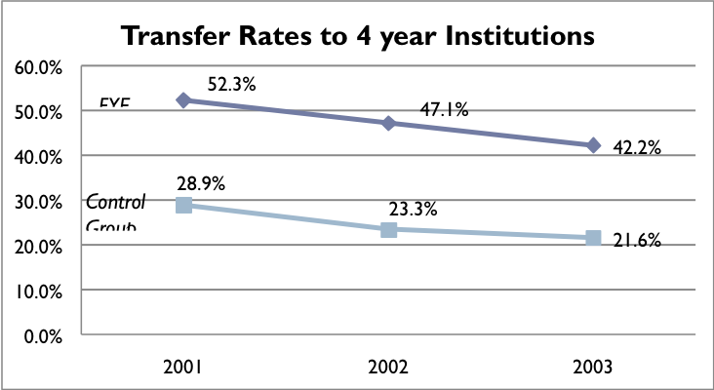

Figure 1. FYE transfer rates

- The 2001 cohort had a 52% transfer rate while the 2002 cohort saw a
lower rate of 47%. Transfer rates for the 2003 cohort decreased by 5
points to 42%. However, FYE students transfer at a higher rate in
comparison to their control groups.

- Interestingly, 91% of the 4-year transfer students in the 2001 cohort
received a Bachelor’s degree with an average time to degree of 6 years. Although later cohorts have not achieved this high rate of degree
attainment, tracking results for the next few years should show an
increase in degrees received. The Office of Institutional Research is in
the process of compiling data for the 2004 & 2005 cohorts.

- Nearly half (47%) of the FYE 4-year transfer students were Latino.
The 2nd largest ethnic group was African-Americans, comprising 21%
of transfer students entering a 4-year institution. They were followed
by Asian/Pacific Islander (12%) and White (11%) students.

The Office of Institutional Research was only able to provide data for the 2001-2005 cohorts because community college students are given at least 6 years to complete their educational goals. The California Community College Chancellor’s Office developed the following transfer rate methodology: The “Intent-to-Transfer” cohort (which becomes the denominator in the transfer rate calculation) includes those students who:
1. Begin college as first-time students in a fall term, and
2. Attempt transfer-level math or English within 6 years, and
3. Complete at least 12 units in the California Community College system within 6
years.

FYE has already submitted a research request for additional transfer data on the 2004 and 2005 remaining cohorts after the intent-to-transfer cycle has been completed.

Efficiency Study
During the fall of 2012, Vice President of Student Services, Dr. Jeanie Nishime, requested an efficiency study be conducted by the Office of Institutional Research regarding the effectiveness of the First Year Experience Program. I have highlighted some of the findings below:

- Students who participate in the First Year Experience Program (FYE) need
fewer courses in English and math to successfully complete transfer-level English and college math courses than freshman who did not participate in the program.

- FYE students were more likely to reach the 30-unit threshold faster than students who do not participate in FYE, achieving 30 units nearly one term faster than freshman who were not in the program. A number of research reports conducted by the RP group have shown that the quicker students accumulate units, the more likelihood they are to complete their educational goals.

- FYE students were more likely to persist into their second year at El Camino College than students who did not participate in the program.

- FYE students were more likely to transfer to a four-year university than students who did not participate in FYE. There is a 20-25 point difference for students participating in FYE.

The findings highlight the effectiveness of the First Year Experience Program in helping students transition to college successfully as well as acclimate to the campus community and thrive while attending El Camino College.

List notable achievements that were linked to the College’s Strategic Initiatives that have occurred since the last program review.
Under Strategic Initiative 1.a “Enhance college services to support student learning using a variety of instructional delivery methods and service." In Fall of 2010, FYE piloted accelerated reading and writing learning communities designed to help students fast track into college level writing (English 1A) within a one semester format. The Office of Institutional Research assessed the effectiveness of the pilot and found that 31% of the students who participated in the accelerated English cohort successfully completed transfer level English compared to 10% and 3% of the English 82 and English B comparison groups.

Under Strategic Initiative 1.a “Enhance college services to support student learning using a variety of instructional delivery methods and service.” In spring of 2014, the FYE program worked with English and reading faculty to redesign the accelerated English program since the pilot was coming to an end. In fall of 2014, the FYE program will pilot a new accelerated program that combines both reading and writing into one course. The new course will be called (English 50RWA) and FYE will pilot a total of six sections in the fall 2014 semester. The program went from a 12-unit program to a 5-unit course that will reduce the cost and hours a students spends while participating in the accelerated program.

Under Strategic Initiative 1.b “Maximize growth opportunities and strengthen programs and services to enhance student success.” The FYE program revamped the recruitment model to address the new mandates under the Student Success Act and moved up the outreach and recruitment model to help students complete their assessment, orientation, and educational plan within a timely period. The program began visiting high schools as early as October 2013 to inform students of the new Student Success Act changes and began educating students about the importance of completing all requirements in a timely manner.

Under Strategic Initiative 1.b “Maximize growth opportunities and strengthen programs and services to enhance student success.” FYE overhauled their counseling model to address the need of new students needing an educational plan before the March 31st deadline. FYE hosted over 15 information sessions (281 students attended) in the evening as well as 6 group counseling sessions (118 students attended) to assist students with the matriculation process.

Under Strategic Initiative 1.b “Maximize growth opportunities and strengthen programs and services to enhance student success.” FYE completed graduation evaluations for current and past cohorts during the spring of 2012, 2013, and 2014 semesters and were successful in processing 187 student graduation petitions for FYE students. Further, another 47 students will submit graduation petitions for summer of 2014. FYE has been actively involved in the Graduation Initiative Program and works closely with the Grant Coordinator, Idania Reyes.

What prior program review recommendations were not implemented, if any, and why? What was the impact on the program and the students?
In the previous program review, it was recommended that FYE receive a full-time academic advisor and the FYE counselor/coordinator release time be increased from 50% to 100% coordinator. The FYE advisor position has been ranked as high priority by the Enrollment Services Division among managers and has been ranked a top priority by Cabinet, but the position has not been approved due to funding. Further, the FYE coordinator position release time has not been approved due to funding. The impact has occurred in the areas of outreach, recruitment, counseling, and the number of students that can participate in the program.

Student Area Outcomes (SAO)
Describe how program personnel are engaged in the creation, discussion, and review of SAO - statements, assessment results, and reports.
The people involved in the SAO process include FYE Coordinator, FYE counselors, advisors, and FYE secretary. Student Area Outcomes statements, assessment results, and reports are discussed in staff meetings so best practices can be implemented. Student Area Outcomes are created at all levels and in categories that include the following areas: orientation, linked courses, program workshops, and overall quality of program services.

How does the program ensure that SAO’s are assessed consistently?
The FYE Program sets specific deadlines to stay on track for timely completion of each section of the SAO cycle. Further, the program has developed an internal SAO calendar for SAO's that need to be assessed each semester. All survey methods are ordered ahead of time from the Office of Institutional Research so that each SAO is administered efficiently. FYE has utilized the following to conduct SAO assessments:
- Pre/Post questionnaires
- Online surveys
- Mid-semester survey
- Interviews

These are methods that have been used to improve services within the FYE program. The program has shared some of these surveys with other programs on campus as well as off campus programs to find better ways of assessing the effectiveness of their delivery services.

Have the SAO assessment results indicated the need to change or modify components of the program? If so, were the changes implemented?
The SAO assessment results have resulted in several changes since FYE began the process. Changes were made to the overall design of the FYE orientation and a new workshop on "How to use MyECC" was included as a result of the SAO process. Second, a questionnaire was provided to student’s mid-way through the semester to provide direct feedback on the strengths and weaknesses of the learning community. This change provided helpful feedback to FYE instructors and allowed them to modify their curriculum. In fall of 2013, we administered a new SAO during our freshman orientation and found that some of the needs of students have changed as a result of recent school shootings. Students reported that they wanted to know more about campus safety, crime statistics, and campus police services offered to students. Because of the latest findings, FYE will include a presentation about campus safety in the upcoming fall 2014 orientation.

Program Improvement
Explain what changes need to be considered to improve the program.
There are three critical areas that need to be addressed in order to improve the program but to also sustain gains made within the last 10-15 years. I have highlighted a list of improvements that need to be considered within the next 5-10 years if the program is to sustain its current model of success:

- The program requires full-time advisors and not casual workers to assist students with financial aid, university applications, scholarships, and additional duties. Casual workers are limited to the number of days they can work and this is problematic to the recruiting cycle of the program and as a result both advisors need to stop working in early May. Our recruitment cycle during the months of May, June, and July are extremely heavy because of the influx of new students to the program and the loss of advisors reduces the number of students we can matriculate in a timely manner.
- The program has a high turn over of part-time counselors because many of them eventually leave for full-time work at other campuses. The program requires at least one more full-time counselor to assist with the current caseload of over 1,000 students per academic year.

- The program requires a full-time faculty coordinator. The program is growing from 700 to 1000 students by fall 2014 and the duties of the FYE coordinator will also increase as a result of the increase in students. The FYE coordinator is responsible for student recruitment, orientation, management of student database system, personnel, high school partnerships, training, and overall program duties. Further, the FYE coordinator position is also responsible for counseling students on a weekly basis.

What activities has the program engaged in to improve services to students?
The program engages in a number of services to improve services to students starting with providing pathways from basic skills to college level courses within one academic term. The program is experimenting with accelerated cohorts in both reading, writing, and math. Further, the program provides all incoming students with a comprehensive orientation, online educational plan, and enrichment workshops to address study skills strategies. In addition, the program is currently offering two undergraduate research programs at both UCLA and LMU to teach students the importance of conducting research prior to transferring. Both are grant funded and residential programs. Students have an opportunity to work closely with faculty in their prospective majors and conduct research, attend university classes, and participate in a symposium to share their research proposals.

How have program personnel used metrics to improve program services? (Provide metrics from the last four years).
The FYE program uses metrics on a daily basis since 2001. Metrics have been used to monitor and report student success, retention, persistence, course progression, transfer rates, and graduation rates for each cohort in FYE. All of these metrics are then shared with FYE counselors and faculty to better design and improve services for students participating in FYE programs. The following data below was provided by the Office of Institutional Research for fall 2010, 2011, and 2012 as the most recent data demonstrating the effectiveness of the FYE program. Further, the data provided below clearly shows that FYE students continue to outperform students who do not participate in the program by large margins. The data also shows that FYE students are enrolling in courses and passing those courses successfully during their first attempt. Second, the data shows that students are enrolling in developmental English courses and progressing into college-level English classes within one academic year. The success and retention rates below are from the Office of Institutional Research and show the latest findings. FYE students continue to outperform the general population in both student success and retention.

Success and Retention Rates
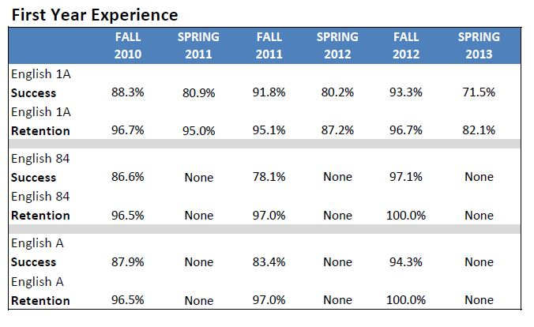

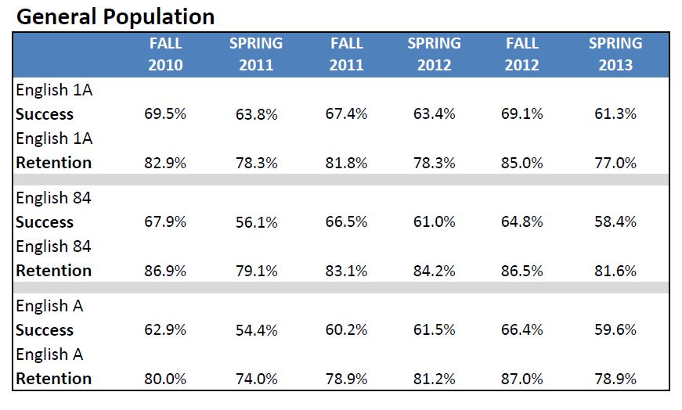

If applicable, explain any patterns in student success, retention, and persistence in terms of student characteristics and program objectives and discuss planned responses or changes.
In fall of 2010, FYE piloted an accelerated learning community in which a cohort of students enrolled in English B and English 82 during the first eight weeks of the fall semester. FYE students who were successful at the end of the first eight weeks continued into the subsequent eight weeks and were enrolled in English A and English 84. A total of 35 students participated in the cohort; 48% were female, and 52% were male. At least 68% of the students were of Hispanic background, the second highest was Asian/Pacific Islander with 16%, the third group was made-up of African American students at 8%, and the remaining group were Caucasian/White students at 4%. At least 92% of the students were full-time and another 8% of the students were part-time. All of the students were first-time students with no prior college units. Over 76% of the students declared transfer as their primary educational goal and another 12% were undecided in their educational goal. The remaining 12% were interested in vocational programs such as nursing and or fire science. At least 28% of the students in the program were English as Second Language learners and 56% of the students in the cohort were first generation college students.
This accelerated learning community format allowed students to complete both basic and developmental English courses in one semester as opposed to the traditional time length of two semesters needed to meet eligibility for English 1A. Students were able to accelerate at a faster pace and enroll in English 1A for the spring of 2011 semester. The retention rate for this pilot was extremely high with 95% of the cohort still remaining until the very end of the academic semester. At least 95% of the cohort passed the first two set of courses (English B & English 82) during the first eight weeks of the semester. Another 88% of students passed English 84 in the second eight weeks and 94% of the cohort was successful in passing English A. Currently, the overall campus success rate for students enrolled in non-accelerated English courses is only about 63.8%.
This coming fall, FYE will pilot another link with two new faculty teaching in the accelerated format. In spring of 2012, FYE plans to increase the number of faculty participating in the program by offering between 6 or 7 additional accelerated links. Further, FYE/SI will pilot a math blended pilot program in fall of 2011 in which students will be given the opportunity to take two math courses concurrently in both basic math and elementary algebra. FYE/SI will pilot three cohorts for the fall 2011 semester and 105 students will be part of the program's first round of blended math courses.
The data shows a strong need to increase the amount of accelerated links currently being offered through FYE. Further, the students in the cohort completed an evaluation survey of the accelerated link experience and at least 96% of the students reported having a positive in-class experience. Another 96% of the students reported that they would recommend the accelerated link experience to other students if given the opportunity. FYE will need additional resources to increase the number of accelerated sections in both basic and developmental English courses. Faculty will need to be trained along with an increase in counseling support services. These two components are critical to the future success of accelerated learning communities. Further, qualitative data has been conducted by the UC/ACCORD research center (funded by the Bill & Melinda Gates Foundation) at UCLA and they have compiled the following data after conducting interviews with students who participated in the accelerated links. Below are themes that emerged from the interviews:

- The Culture of the FYE Classroom:
Students we have interviewed describe their English classroom as a place where they feel comfortable and supported by their peers, particularly by the instructor, Mr. Pete Marcoux. Based on what the students are sharing with us in the interviews, the culture of the classroom is established by Mr. Marcoux, who projects a sense of 1) genuine caring of student success and, 2) support that will encourage that success. This culture is set by the instructor and tied to the learning community environment of the classroom. Students have shared that they feel like this learning community is a “family” and that they support each other inside and outside of the classroom. Several students mention that they study with their cohort peers outside of class and have developed social relationships with each other outside of school. Students in the cohort independently created their own Facebook page which illustrates the sense of community fostered by the link. The combination of the efforts of the instructor and the learning community environment seem to have created a classroom culture where the students can see and perform their potential.

- FYE Services:
Based on our interviews, the FYE services that are readily available to students are another important component of their ability to successfully complete these courses. Students have shared that they know they can visit the FYE office to find answers about course planning, major/minor course requirements, and financial aid. All 11 students in this sample were the first in their family to attend college and seemed to have limited access to college information prior to enrolling at El Camino. As a result, having a centralized place on campus to gain college information seems to play a critical role in the decisions students are able to make and also contributes to the ways they feel supported as FYE students. Students have most frequently mentioned the counseling services being the most helpful. In particular, they mention Ramon Franco and Dr. Cynthia Mosqueda (most frequently) as staff that they feel they can relate to and who they feel confident will be able to help find answers to their questions.

- Learning to be “Successful Students”:
A final theme that seems to support student success of those we have interviewed is learning the skills students need to be successful college students. Many of the students mention specific skills they have learned in the English 82/84 series that have helped them become better readers and writers. For example, one student mentions how she has learned to use “context clues” in reading a text when she does not know the meaning of a word. She described that when she finds a word she doesn’t know, she will now read the sentence or paragraph the word is in, in order to decipher the meaning. Several students mention that they did not like to read books, and now enjoy it because they have learned how to read and analyze a text. One student shared in an interview how he had already bought and began reading the text for the following English course (English 1A) during his winter session break because he wanted to get a “head-start.” Most impressive is that this student also shared that previously, he had never read more than the first few pages of his class texts.

Accelerated English–Course Progression (fall 2012 Cohort)
The fall 2012 Accelerated English cohort along with English 82 and English B comparison groups were tracked from fall 2012 through summer 2013. The English 82 and English B comparison cohorts are students who first attempted their respective English courses in fall 2012.

- 90% of students who passed both English 50RR and 50WW enrolled in transfer level English while 54% of the English 82 cohort and 14% of the English B cohort who passed their respective courses enrolled in transfer level English.

- 31% of the Accelerated English cohort successfully completed transfer level English compared to 10% and 3% of the English 82 and English B comparison groups, respectively.

21 Failed to Pass
44
Failed to Pass
Transfer Level

Engl 50RR
Engl 50WW
60 Passed
33 Passed
Fall 2012 FYE Accelerated English Cohort (N=104)
90% persist
58% pass
61%
104 Enrolled
54 Enrolled
6
Not Enrolled in Next Course

20 Failed to Pass
88 Failed to Pass
224 Failed to Pass
Develop. Reading

Intro to Reading

Transfer Level
389 Passed
151 Passed
60 Passed
Fall 2012 English 82 Comparison Cohort (N=613)
61% persist
53%
60%
63% pass
63%
80 Enrolled
613 Enrolled
239 Enrolled
150
Not Enrolled in Next Course
71
Not Enrolled in Next Course

5 Failed to Pass
63 Failed to Pass
112
Failed to Pass
Develop.
Writing

Intro to Writing

Transfer Level
250 Passed
105 Passed
10 Passed
Fall 2012 English B Comparison Cohort (N=362)
67% persist
14%
67%
69% pass
63%
15 Enrolled
362 Enrolled
168 Enrolled
82
Not Enrolled in Next Course
90
Not Enrolled in Next Course

The findings of the most recent accelerated study clearly show that students who enroll in fast track courses are more likely to be successful in the accelerated reading and writing program than in the traditional basic skills pathway. In fact, 31% of FYE students were successful in completing basic and developmental reading and writing as well as completing college level English, while only 10% and 3% of the comparison group. The Student Success Act has recommend that colleges examine new ways of getting students through the basic skills pipeline faster and FYE’s accelerated program is addressing those needs.

Program Environment
Discuss the program environment, including the relationship among program staff and students and involvement with other programs or support areas.
The FYE program works closely with adjunct counselors who provide the following services: academic planning, career counseling, transfer, and graduation evaluations. FYE also has two academic advisors that assist students with financial aid questions, MyECC, and transfer application information. Further, FYE works closely with instructors from nearly all divisions across campus as well as the academic deans. Faculty and staff have a strong relationship and usually meet their students before the start of the fall semester. FYE faculty interact with students during the orientation process. Further, faculty and staff attend several meetings throughout the academic semester to discuss the progress of each cohort and how we can better improve services.

Describe the number and type of staff and faculty (include current organizational chart).
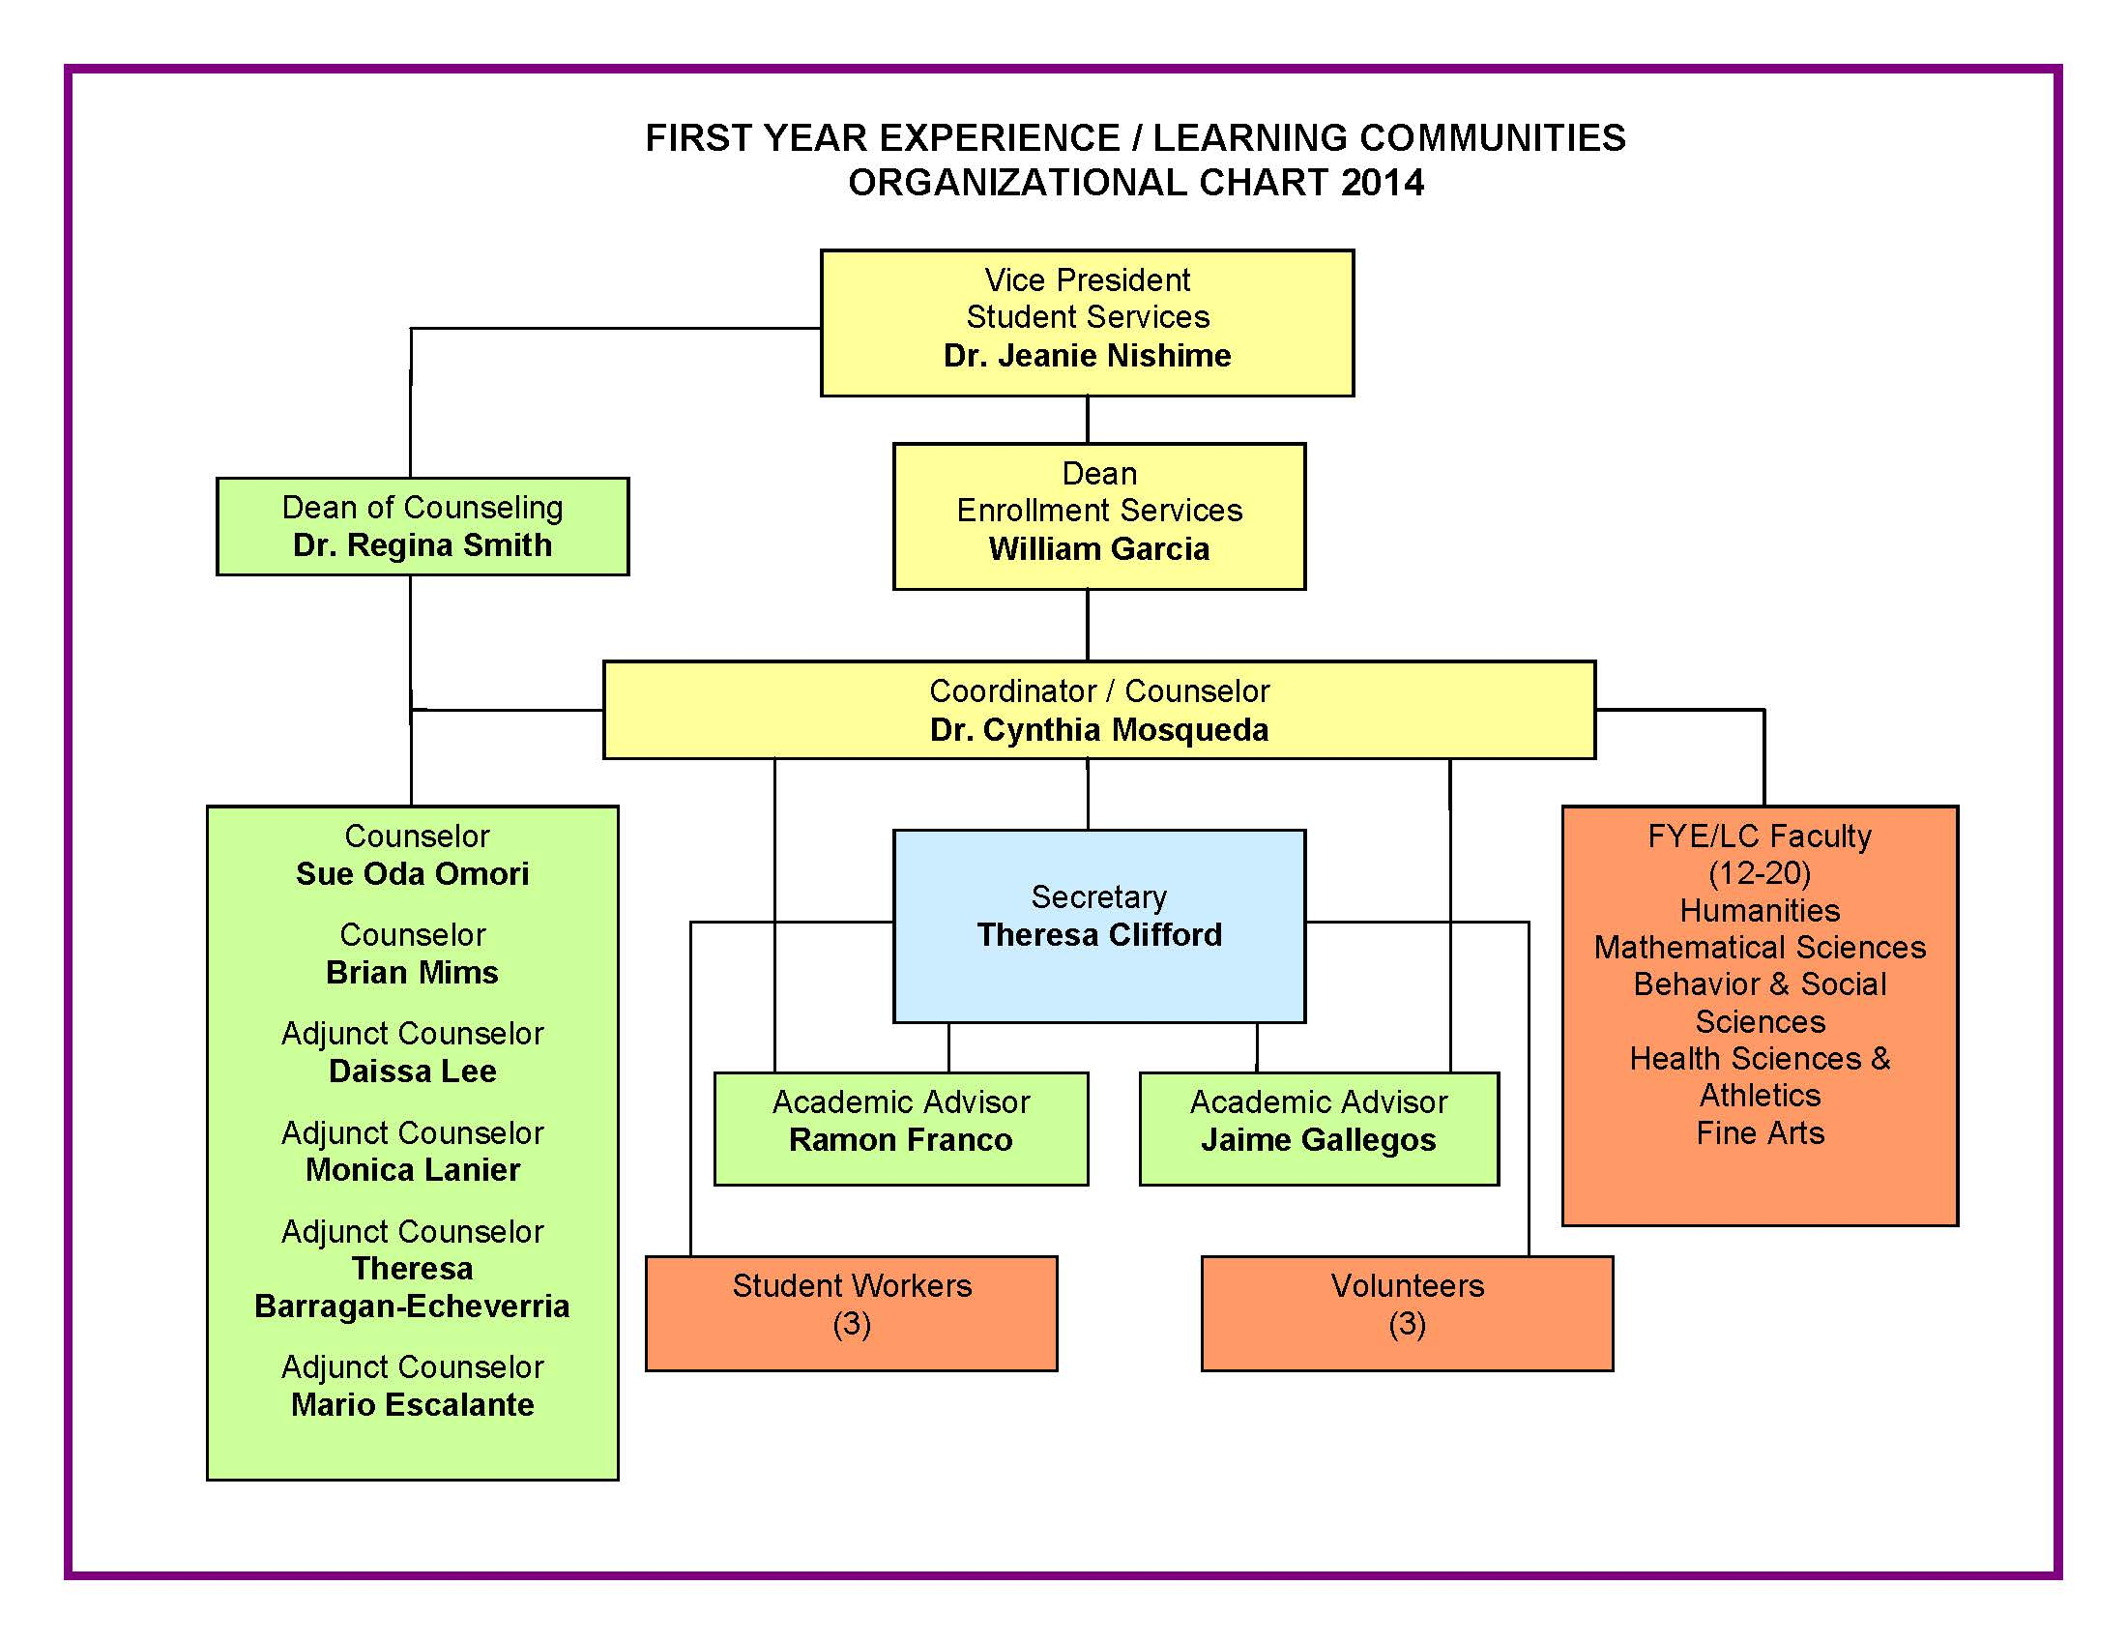

Describe facilities or equipment needs for the next four years.
The FYE program recently received new computers for all counselors and staff working in the program. The only needs for the next four years are student computer space. The program receives a steady amount of students on a weekly basis in the center and many of those students utilize FYE computers to check their MyECC, apply for financial, process their dream act, and apply for transfer.

Describe how well the scheduled hours of availability meet student demand and indicate the specific hours the program operates.
The current schedule of hours is sufficient for the program because the majority of the students work in the afternoon and the flexibility of scheduling counseling appointments or seeing a walk-in advisor from 8:00 a.m. - 4:00 p.m. is convenient for the majority of our students. Further, counselors frequently visit FYE classes during these hours to conduct in class orientations or give students updates about college events and transfer information.

Describe the influences that external factors such as state laws, changing demographics, and the characteristics of the students served have on the program and services and how the program addresses these factors.
The most pressing change in state law has been the passing of the Student Success Act. FYE has been proactive in ensuring that we are meeting the new mandates as it relates to assessment, orientation, and educational planning. FYE increased the number of information sessions offered each month to accommodate more students throughout the academic year. FYE scheduled numerous group counseling sessions to assist students with abbreviated educational plans. Further, FYE worked closely with the Office of Outreach and Student Relations to coordinate testing dates at feeder high schools. FYE also increased the number of high school outreach presentations conducted throughout the academic year to accommodate a larger number of students.

Conclusions and Recommendations
Present a brief summary of the program’s strengths and areas for improvement. List all recommendations in a prioritized manner for subsequent placement into the program’s annual plan.
The strength of the program has been to offer academic counseling and learning communities that link basic skills, developmental, and college transferable courses. The success for students participating in the program has ranged from 80%-90% and close to 90% of our students are retained beyond their first year in college. Second, FYE students are more likely to pass their English and math classes their first time around than students who did not participate in the program. Third, FYE’s model encourages students to complete their developmental courses within their first year of college. This practice has resulted in students expediting their ability to enroll in college level courses going into their second year of college and increasing the number of degree applicable and transferrable courses so that students can decrease the number of semesters needed to earn their degree and or transfer.
Most recently, FYE has taken a special interest in the undocumented (AB540) student population and has worked closely with this group of students to offer advising, orientation, and help with the Dream Act application. FYE has offered workshops in partnership with the Financial Aid office to make sure they are afforded the same opportunities as are non-AB540 students. Further, the cohort model has been an effective means of reaching a larger audience of students while at the same time providing personalized orientations, counseling, academic advisement, and transfer assistance. The collaboration between FYE staff and instructional faculty has also been a major strength of the program.
The weakness of the FYE program has been the student to counselor ratio and the inability to keep consistent counselors throughout the entire academic year. The program utilizes and trains part-time counselors and many of them will leave for full-time employment or for more hours within other programs on or off campus. The amount of counseling staff is inadequate to accommodate a growing FYE program. Efforts have been made to keep the FYE program to a manageable number of students so the counselors will not be overwhelmed. This has inhibited the growth and development of a very successful program. The program’s 3-5 year direction is to request two full-time counselors and one full-time advisor to assist with the growing number of students participating in FYE. Further, the program is planning on growing the number of basic and developmental accelerated English learning communities currently being offered on campus. FYE plans to pilot an upcoming accelerated reading and writing program (English 50RWA) in fall of 2014 that will help accelerate the developmental pathway for community college students. FYE has taken the lead in the accelerated movement across the state and is working with other campuses to learn how they can start their own accelerated program. Last, the program is experiencing growth for fall of 2014 and previous research conducted in fall of 2005 by former researcher, Phil Dykstra, revealed that when the program grew the success of the program also declined if student support services were not also increased. FYE will need to increase the student support services that take place outside the classroom and ensure that it is adequate to accommodate the new number of students participating in the program. The limitations of the faculty coordinator, advisors, and part-time counselors is by far the greatest challenges the program will face in 2014.

List prioritized recommendations. (Provide proposed organizational chart if appropriate).

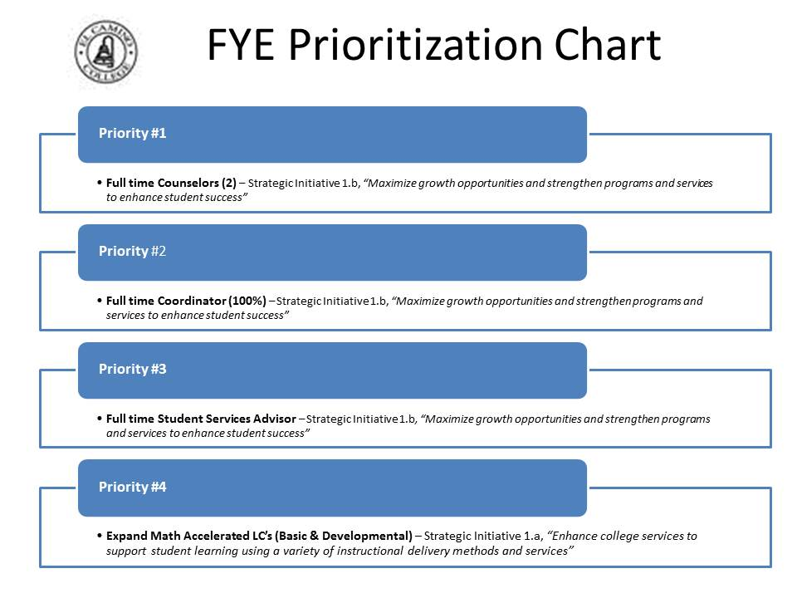

_X_ Continue Program

___ Discontinue Program (Explain how the program’s services could be handled by other services on campus if the program has been declining or is no longer fully utilized.)

The First Year Experience Executive Summary provided by the Office of Institutional Research.
The FYE Transfer Study provided by the Office of Institutional Research 2010.

