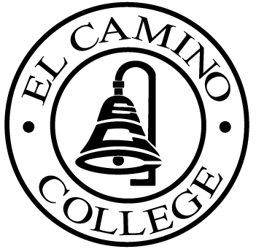

EL CAMINO COLLEGE

Office of the Vice President - Administrative Services

AGENDA
CITIZENS’ BOND OVERSIGHT COMMITTEE
El Camino College
Administration Building – Board Room
May 18, 2011
3:00 p.m.

1. Open Meeting 3:00 .

2. Approval of March 18 Minutes

3. Measure “E” agenda Bob Gann
- March 21, 2011
- April 18, 2011

4. Selection of Chair & Vice Chair All Members

5. Schedule of Future Meetings Chair

7. Open Discussion All Members

8. Public Comment Public

9. Adjournment

PURPOSE: To inform the public concerning bond revenue expenditures and to actively “review and report” on the expenditure of these funds. (Ed. Code sec. 15278(a)

