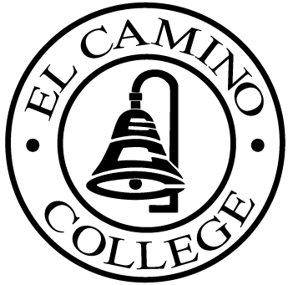

EL CAMINO COLLEGE

Office of the Vice President - Administrative Services

AGENDA
CITIZENS’ BOND OVERSIGHT COMMITTEE
El Camino College Board Room
November 9, 2005
3 p.m.

1. Open Meeting Kurt Weideman 3:00

2. Approval of September 14 Kurt Weideman 3:00 – 3:05 p.m.
Minutes

3. Measure “E” Agendas Bob Gann 3:05 – 3:15 p.m.
-September 12
-October 17

4. Changes to Bond Projects Bob Gann 3:15 – 3:30 p.m.

5. Auditor Selection Kurt Weideman 3:30 – 3:40 p.m.

6. Annual Report Kurt Weideman 3:40 – 3:50 p.m.

7. Schedule of Future Meetings Kurt Weideman 3:50 – 3:55 p.m.

8. Open Discussion All Members 3:55 – 4:05 p.m.

9. Public Comment Public 4:05 – 4:15 p.m.

10. Adjournment Kurt Weideman 4:15 p.m.

PURPOSE: To inform the public concerning bond revenue expenditures and to actively “review and report” on the expenditure of these funds. (Ed. Code sec. 15278(a)

